**Index**

1. Software Requirement 1

1.1. Introduction 1

1.1.1 Aim of the document 1

1.1.2 Overview of the defined system 1

1.1.3 Related system, Pros and Cons 2

1.2 User Stories 2

1.3 Functional Requirements 3

1.4 Use Cases 4

1.5 Dictionary 5

Follows a Dictionary, where all technical terms used in Software Requirements section are defined. 5

2. StoryBoards 5

3. Design 11

5. Code 14

# 1. Software Requirement

# 1.1. Introduction

## 1.1.1 Aim of the document

The document covers a description dealing with general aspects of the system, differences with related systems, Requirements, UML diagrams, storyboards of GUI prototype and links pointing to the repository in GitHub and the overview page of SonarCloud.

The requirements are divided in User Stories (9) and Functional Requirement (9).

The UML diagrams are divided in Use Cases Diagram (1) and Activity Diagram (3).

## 1.1.2 Overview of the defined system

The system implements method for exchange favors between users. A user can request a favor to all users, posting an ad which details the favor, or request a favor from a specific user, answering to an ad where the publisher makes himself available for doing that favor.

When an ad is published, it becomes active until it’s closed by the user or it’s active time expires.

A user can find an ad by browsing a wall or using a pinpoint map, where active ads are displayed by their proximity to the user location.

A user can make his profile visible to Company Talent Scouts in order to allow them to contact him if they want to be hired by them.

## 1.1.3 Related system, Pros and Cons

The system is built following the model of trading site “Subito.it” where users can buy or sell an item using posts. A main difference between them is that the communication between users happens inside the system unlike “Subito.it” where it happens providing telephone number or sending emails.

# 1.2 User Stories

More User Stories can be found in the repository on GitHub, among tickets labeled “User Stories”.

User Stories written by Lorenzo Mei (lorenzomei):

* As a user, I want to know the location of the advertiser, so that I can know which ones are in my local area, 10 km at most (ticket #5);
* As an advertiser, I want to publish ads, so that I can inform the other users that I need or I can offer a favor (ticket #4);
* As a user, I want to filter the search of ads, so that in my search there aren’t unwanted results. (ticket #2).

User Stories written by Mihai Jianu (mihaiJianu):

* As a new user, I want some free token, so I can request a favor without offering one before (ticket #18);
* As a user, I want to view the profile of other users, so I can know the person’s characteristics (e.g. skills and personal information) before we get in touch (ticket #19);
* As a user, I want to see the reviews about the advertisers, so I can know their reliability reading other users opinions (ticket #20).

User Stories written by Daniele La Prova (Torkin1):

* As a beta tester, I want to use a feedback system, so that I can let developers know my opinion about the software (ticket #10);
* As a veteran user I want to have a favorite user list, so that I can remember who are the best users in my experience (ticket #11);
* As a new user, I want to have a tutorial, so that I may learn how to use the software (ticket #12);

# 1.3 Functional Requirements

All terms written in **bold** are defined in Dictionary section.

Functional Requirements written by Lorenzo Mei (lorenzomei):

* The system shall provide categories with which the ads can be distinguished (like accommodations, botany, hydraulics, and mechanics) (ticket #9);
* The system shall provide the possibility to post an ad with the following frame (ticket #8):  
  • A title, which will summarize the content of the ad;  
  • A tag, that will flag the ad as an offer or a request;  
  • A text box, that will contain the detailed content of the ad;  
  • A dedicated area, where the user can attach videos, documents and pictures;  
  • A feature that allows the users to get in touch.
* The system shall provide a map that pinpoint the location of the advertiser that have an active ad at the moment (ticket #7);

Functional Requirements written by Mihai Jianu (mihaiJianu):

* The system shall provide, a 5-star rating method, (a 1-star rating represents the worst judgment, and a 5-star represents the best one) with a text space, in which the user can add further details about the motivation of the judgment (ticket #17);
* The system shall provide a Wall-like space, where a user can upload their “jobs done” pictures and curriculum-like space where a user can write their skills and personal information (ticket #16);
* The system shall send an e-mail to the first access users that contain a free token as a gift and a welcome message, which greets the user, and explains how to use the token.

Functional Requirements written by Daniele La Prova (Torkin1):

* The system shall provide a tutorial to first-access users, containing the following items (ticket #6):  
  • An explanation about how the user is supposed to use tokens and how to obtain them;  
  • An explanation about how the user is supposed to get in touch with other users in order to exchange favors;  
  • An explanation about how to get in touch with the support team if further help is needed;  
  • A visual demo of how to achieve the steps above.
* The system shall provide the possibility to mark a user as a “favorite” and a section where the user can see a list of users marked as favorite by them (ticket #3);
* The system shall provide an agent available for beta testers, with the following behavior when invoked:  
  • It shall let the tester specify what software features the tester wants to write a report about;;  
  • It shall open up a text box where the tester can write a report about how experienced a software feature;  
  • It shall allow the tester to attach screenshots and videos to the text he wrote;  
  • It shall send a report to the developers via e-mail.

# 1.4 Use Cases

Follows a picture showing an Use Case Diagram summing up what the system is meant to behave by an user perspective.

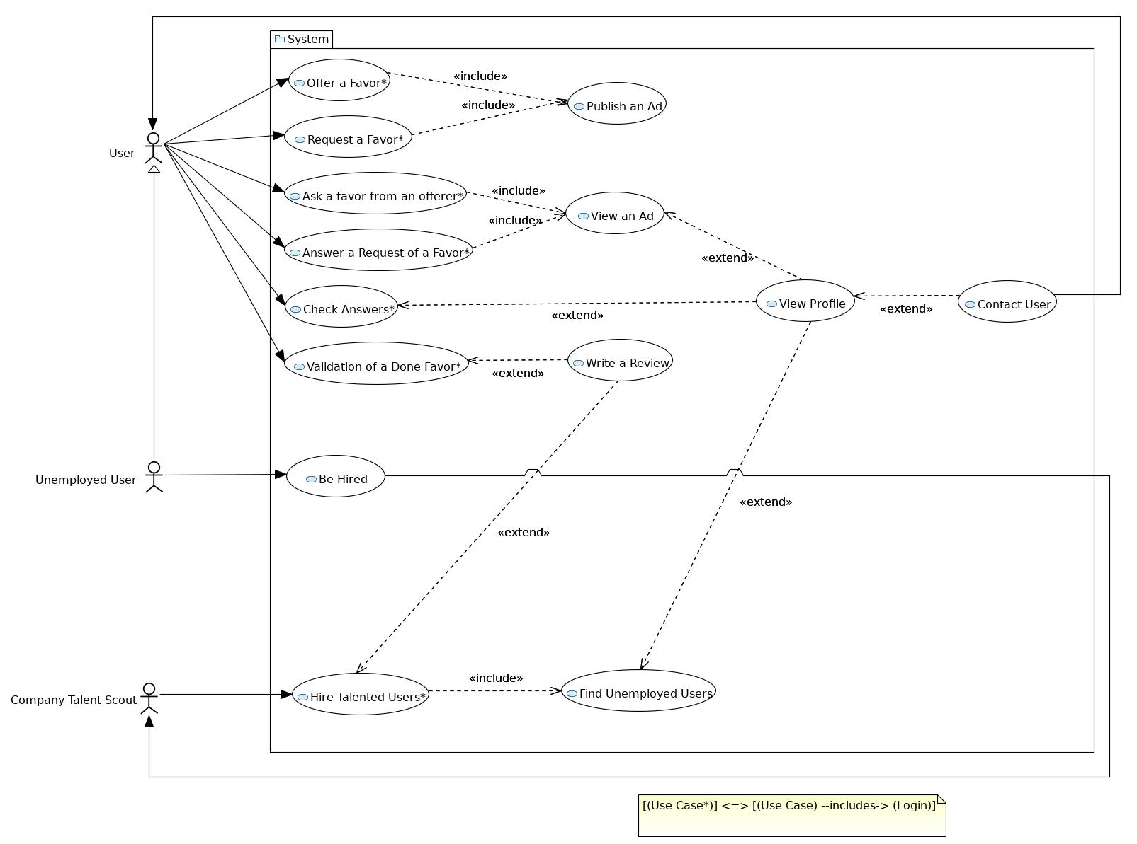  
Diagram 1: Use Case diagram

# 1.5 Dictionary

# Follows a Dictionary, where all technical terms used in Software Requirements section are defined.

|  |  |
| --- | --- |
| **Validation#36** | It's the procedure that will check the authenticity of a done favor and will grant a token to the user that did the favor. |
| **Advertiser#23** | It's the owner of an active post where they request or offer a favor. |
| **Token#22** | It’s the currency used to exchange favors between the users. |
| **Favor#21** | A service that users can request by or offer to other users, through the use of tokens. |

# 2. StoryBoards

Follows a storyboard of six screens showing a GUI prototype of the system.

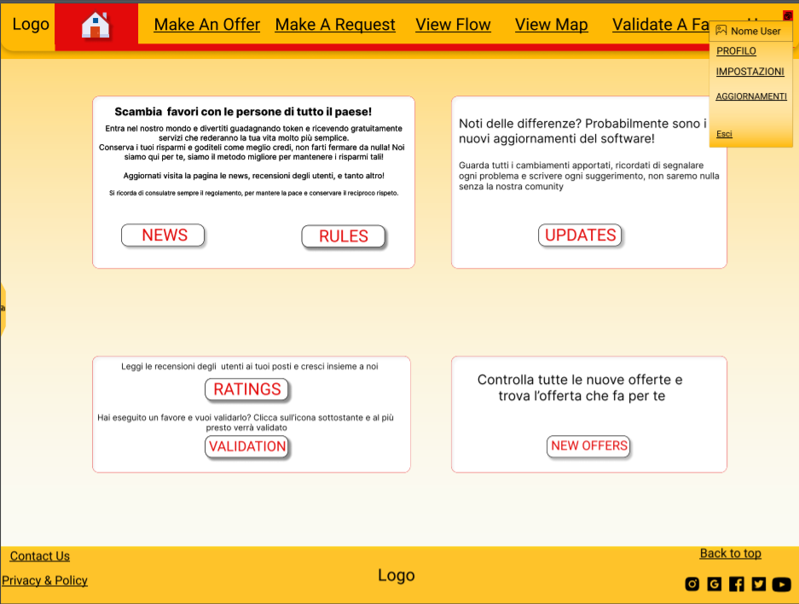  
View 1: Home page. The user can find some useful accelerators here.

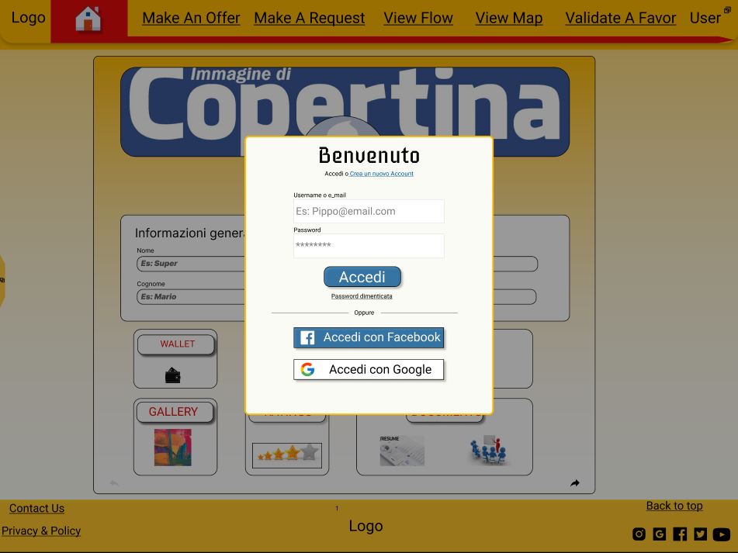  
View 2: Login screen. Other than normally logging in, the user can log in using Facebook or Google account, or register a new profile.

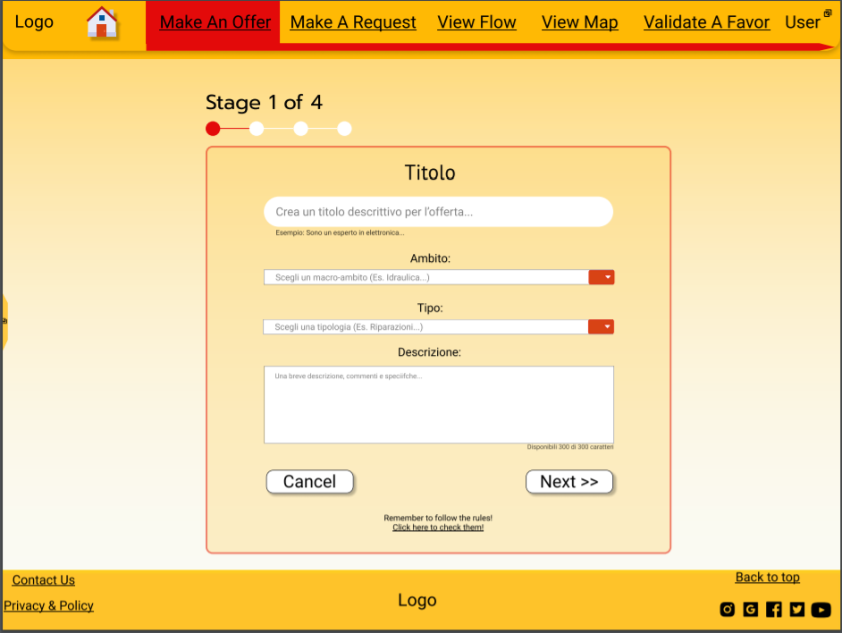  
View 3: Step one of Make an Offer process, where the user can add details in order to describe their offer.

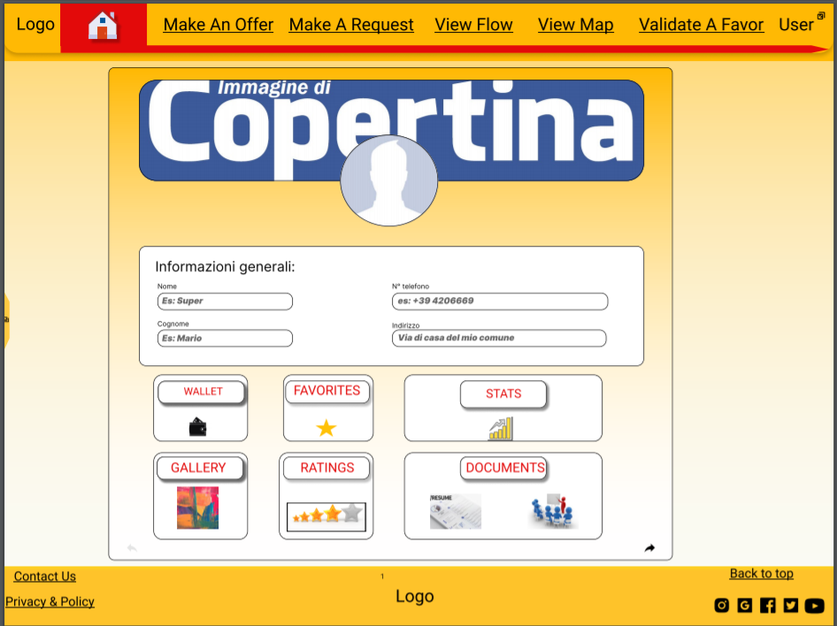  
View 4: User profile main screen. Here the user can browse and modify their personal information.

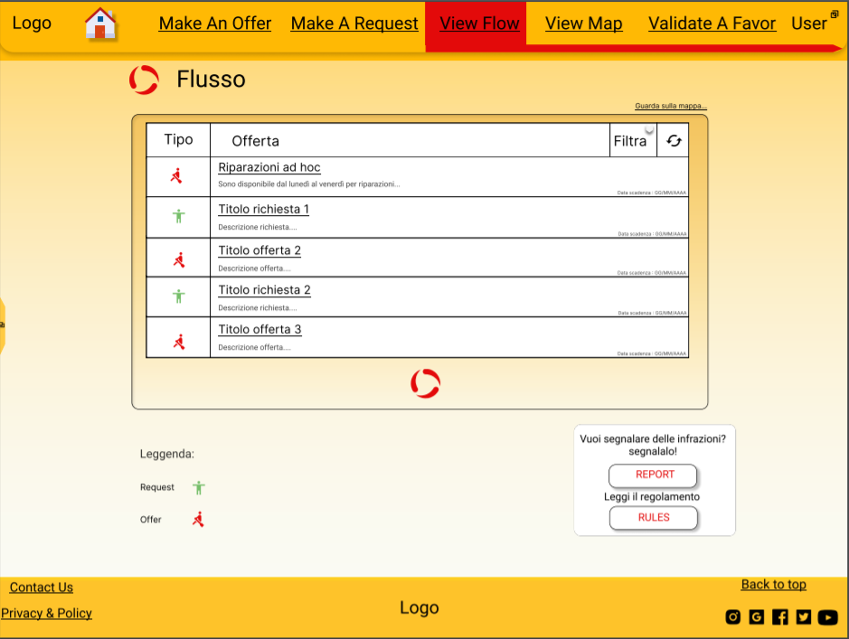  
View 5: Posts flow screen. Posts are listed by date of publication by default.

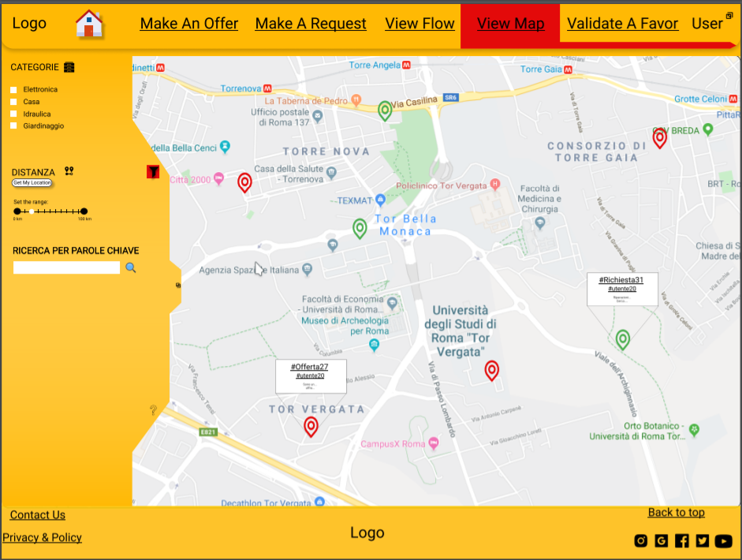  
View 6: Pinpoint map showing nearby offers and requests. Search can be filtered by category, by proximity or by keywords.

# 3. Design

Follow three Activity diagrams, one for each member.

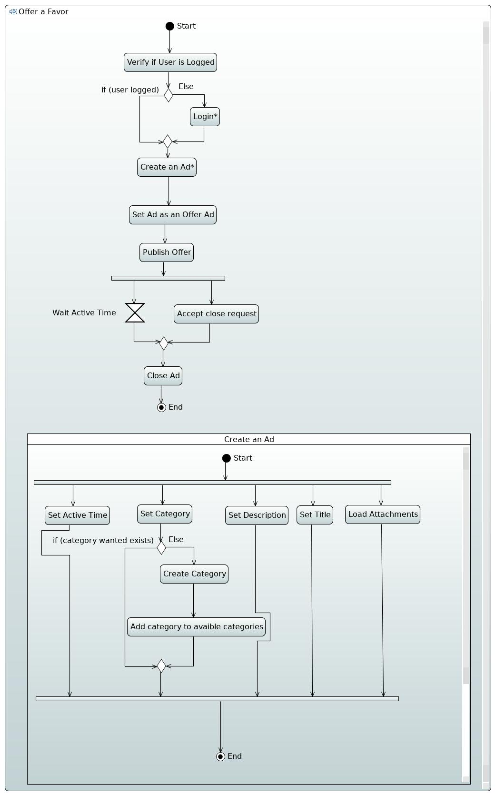  
Diagram 2: Activity Diagram showing Make an Offer Use Case

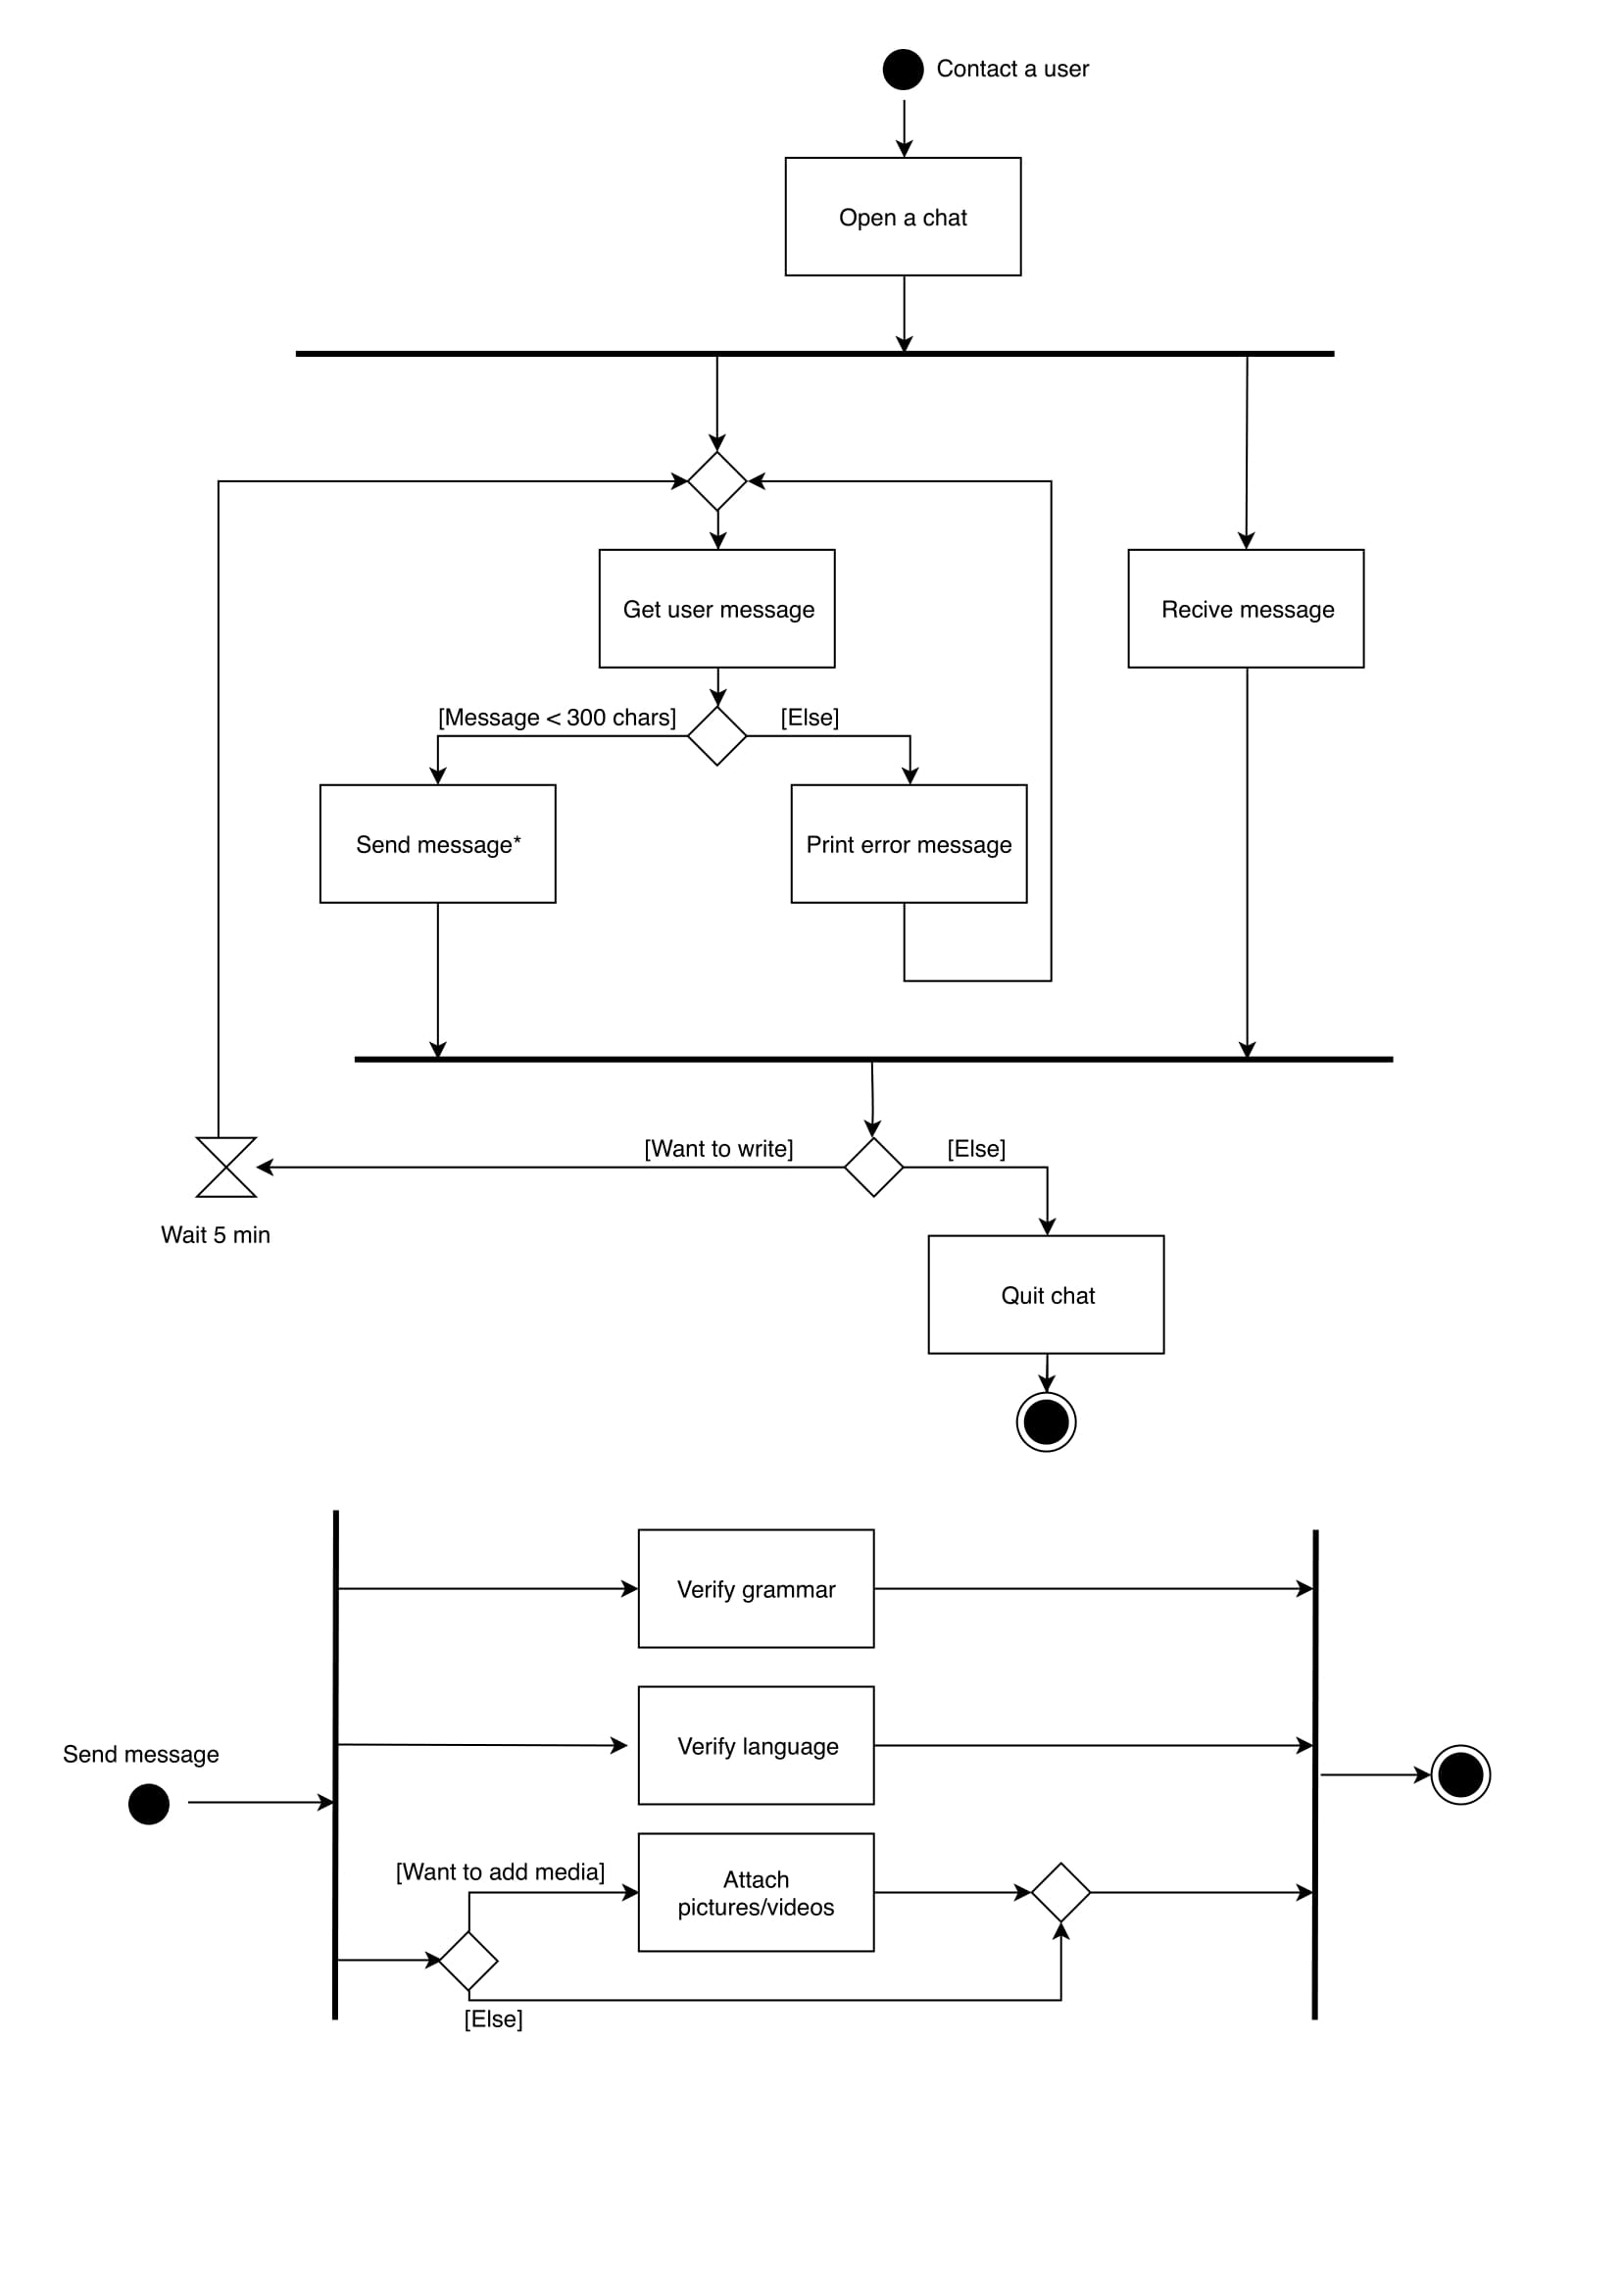  
Diagram 3: Activity Diagram showing Contact an User Use Case

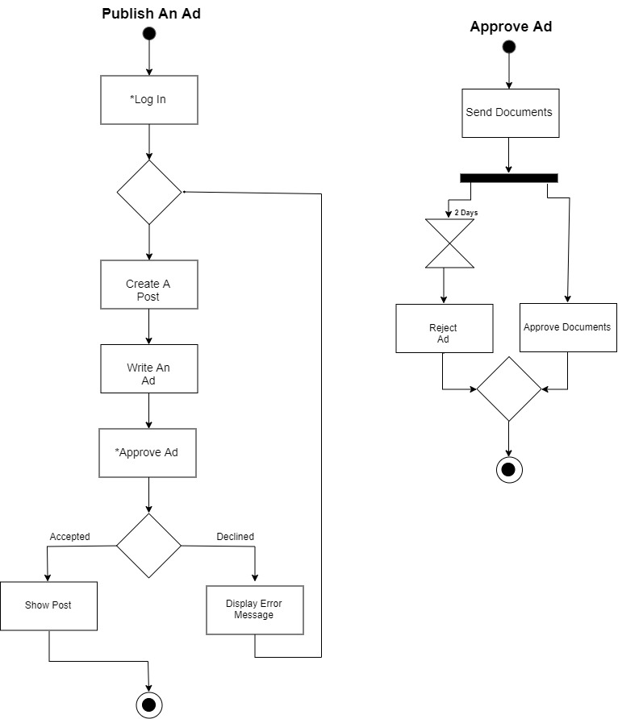  
Diagram 4: Activity Diagram showing Publish an Ad Use Case

# 5. Code

Clicking on a button will open a browser tab with the intended destination.

In the case buttons won’t work, here are the links:

GitHub: <https://github.com/Torkin1/ISPW_project>

SonarCloud: <https://sonarcloud.io/dashboard?id=torkin1_ISPW_project>

# 6. About the authors

Daniele La Prova

Mihai Jianu

Lorenzo Mei